**Buttons and Action Bar**

1. **Action Bar Purpose and Functionality**

The action bar is a feature of android applications which is located at the top of each screen and is generally persistent throughout the application.

It provides several key functions:

* Makes important actions prominent and accessible in a predictable way (such as *New* or *Search*).
* Supports consistent navigation and view switching within apps.
* Reduces clutter by providing an action overflow for rarely used actions.
* Provides a dedicated space for giving your app an identity.

1. **Action Buttons**

Action buttons are contained within the action bar and perform user actions when interacted with. Generally, the most important actions for the current context use this functionality. There is limited space within the app bar so some actions may be contained in the overflow menu.

1. **Action Bar Overlaying**

Action bar overlaying is where the action bar is drawn on top of the activity rather than in its own area of the screen. This way the layout remains fixed when the action bar hides and reappears. When overlay mode is enabled, your activity layout has no awareness of the action bar laying on top of it. So, you must be careful not to place any important information or UI components in the area overlayed by the action bar.

1. **Adding an element to the Action Bar**
   1. All action buttons and other items available in the action overflow are defined in an XML menu resource. To add actions to the action bar, create a new XML file in your project's res/menu/ directory.
   2. Add an <item> element for each item you want to include in the action bar, as shown in this code example of a menu XML file:

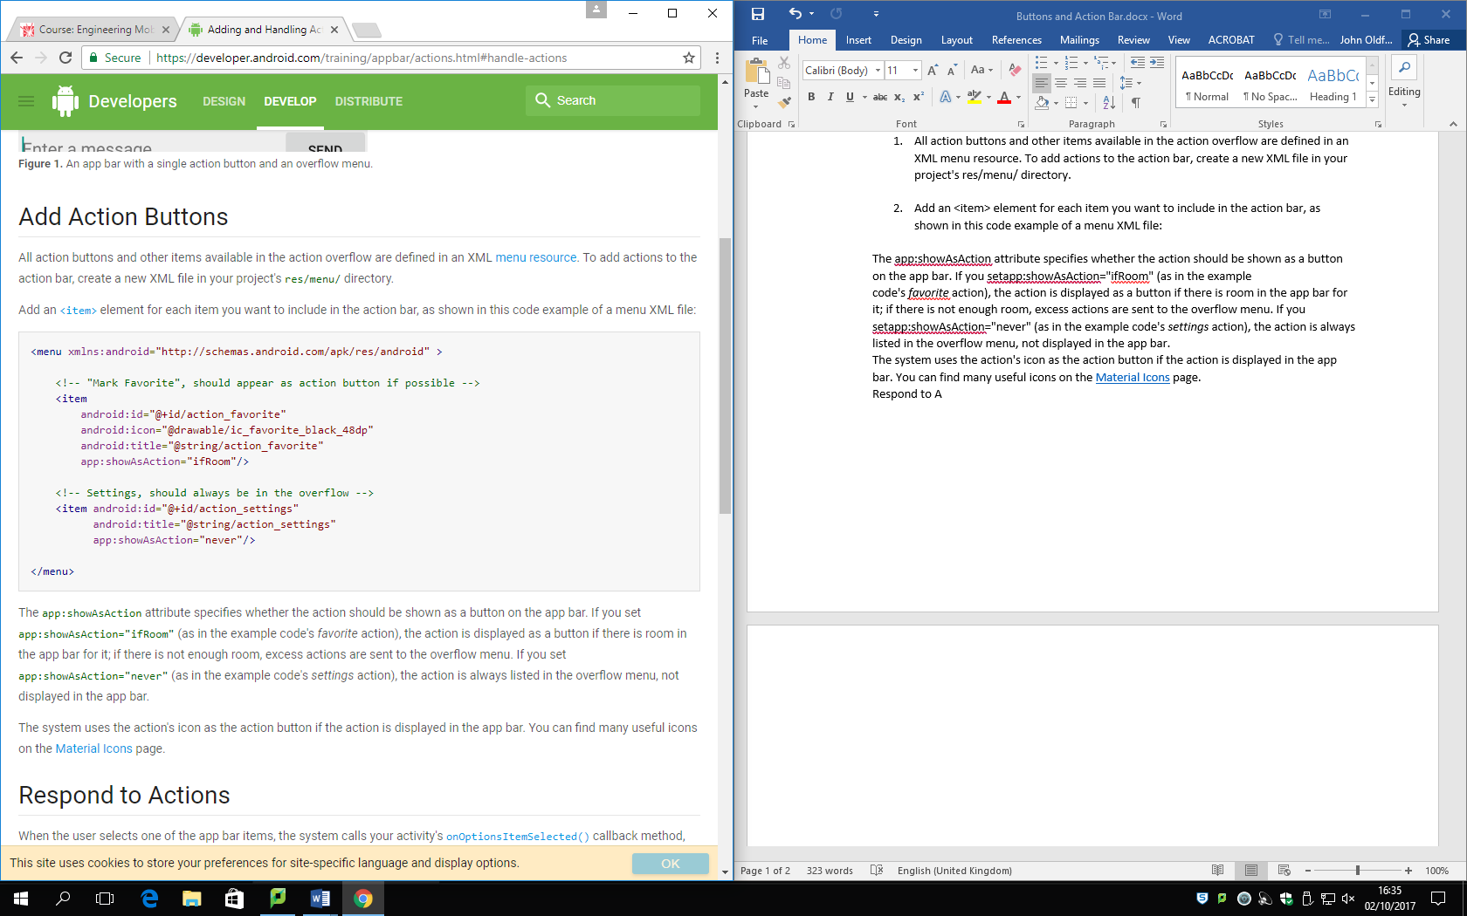

* 1. The app:showAsAction attribute specifies whether the action should be shown as a button on the app bar. If you setapp:showAsAction="ifRoom" (as in the example code's *favorite* action), the action is displayed as a button if there is room in the app bar for it; if there is not enough room, excess actions are sent to the overflow menu. If you setapp:showAsAction="never" (as in the example code's *settings* action), the action is always listed in the overflow menu, not displayed in the app bar.

***The system uses the action's icon as the action button if the action is displayed in the app bar. You can find many useful icons on the***[***Material Icons***](https://www.google.com/design/icons/)***page.***